SRS Arrimage in DETECT — Technical reference
Oct 15, 2026 · @bb2cb

1. Scope
SRS Arrimage is onboarded into DETECT as a new flow (flow_type = "arrimage") that runs two scopes in one DSS flow: stda (two fixed source versions, v2x1 and v3x1) and sgcp (the latest version of each quarter). The DETECT core (pre-processing, models, post-processing) is used unchanged as a black box; Arrimage recipes wrap its functions, with CCIRC as the reference flow.
Scope | Versions read | Entity column | Targets | Axis combinations
stda | v2x1 and v3x1, fixed | cd_pole_pmas | 6: mt_cal_ead_tot, mt_cal_rwa_tot, mt_cal_expo_tot, nb_maturite_irba, tx_lgd_avant_flex, tx_edf_1an_irba | 13
sgcp | latest per quarter | cd_pole_pmas_ap_acc | 8: mt_cal_ead_tot, mt_cal_rwa_tot, mt_cal_prov_gen_aff_tot, nb_maturite_irba, tx_lgd_avant_flex, tx_pd_moyenne, tx_ltv_cur, tx_lgd_irba | 8
- Window: 6 quarters, 2025Q1 to period_run = 2026Q2 (nb_periods = 6).
- Source: DSS dataset uds_fac_arrime, partitioned dt_closing|uds_version (e.g. 2026q2|v3x1), one row per facility (id_fem), counterparty id_tiers.
- Main deliverable: SP_display_toplines, the anomalous segments with the facilities that drive them, consumed by a Tableau dashboard.

2. Flow at a glance
Seven recipes in two branches: the segment branch (SP_agg → SP_anomalies) finds anomalous segments, the line branch (SP_toplines_cumul) keeps the large facilities, and SP_display joins them to show which facilities drive each anomaly.
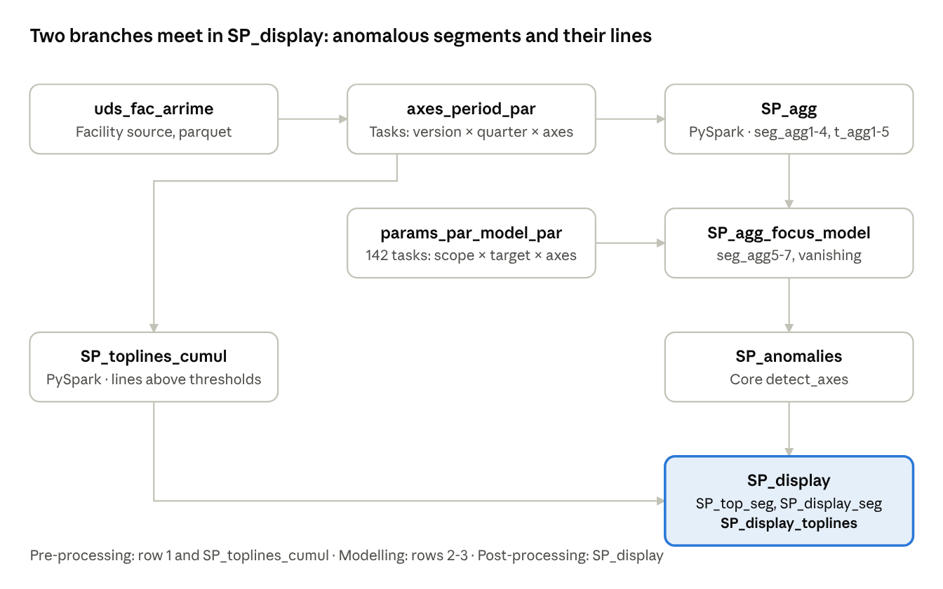
Arrimage flow · 7 recipes, 2 branches
The two PySpark recipes read the source; the later recipes are pandas and run one task partition at a time.

3. stda vs sgcp
The core difference: stda has two parallel versions in the same partition, sgcp has one version that may change from quarter to quarter. Each version is an independent series end to end, tagged by id_set_parameters_clone (arrimage_stda_v2x1, arrimage_stda_v3x1, arrimage_sgcp_latest).
Topic | stda | sgcp
Version choice | Fixed v2x1 and v3x1; a missing fixed version raises an explicit error | latest = highest vAxB among the quarter's partitions
Missing quarters | v3x1 has no 2025Q4 and 2026Q1: skipped with a WARNING, the series has a gap | None
Entity | cd_pole_pmas | cd_pole_pmas_ap_acc
Line ids | id_technique, id_fem, id_tiers, lb_raison_sociale | Same, but id_technique is empty
Rules shared by both scopes
- Reading the source: each partition folder (dt_closing=…/uds_version=…) is read as parquet with mergeSchema=true, not through dkuspark, because some columns (tx_ltv_cur) exist in only part of a partition's files.
- No duplicate facility across versions: v2x1 and v3x1 of the same facility are two rows by design; every group-by, merge and core call is done per id_set_parameters_clone, so they are never summed or joined together.
- One schema per partitioned dataset: DSS keeps the schema of the last partition written and reads every partition with it. SP_toplines_cumul therefore uses the union of all scopes' columns, in a fixed order, targets cast to double and every other column to string.
- Dashboard labels: after the core, id_set_parameters_clone is relabelled stda / sgcp and the version moves to version_clone (v2x1, v3x1, latest).

4. Recipes and outputs
Two PySpark recipes read the source; every later recipe is Python (pandas) and works on one task partition.
Recipe | Engine | Output partitioning | What it produces
compute_axes_periods_par | Python | by scope | One task per (version, quarter, axis combination), built from the source partitions that really exist
compute_SP_agg | PySpark | scope / period_run / id_set_parameters / period | One row per segment × quarter × target × version: seg_agg1..4, t_agg1..5
compute_SP_toplines_cumul | PySpark | scope / period_run / id_set_parameters / period | Facilities above the topline thresholds (EAD or RWA > 5000), with ids and axes
compute_params_par_model_par | Python | none | 142 modelling tasks (stda 78, sgcp 64): scope × target × axis
compute_SP_agg_focus_model | Python | scope / period_run / id_set_parameters / t_variable | SP_agg rows of the task + seg_agg5..7, segments kept if seg_agg5 > 500, vanishing segments added
compute_SP_anomalies | Python | same as above | Core detect_axes: anomaly, deviation, expected_value, materiality
compute_SP_display | Python | same as above | SP_top_seg, SP_display_seg, SP_display_toplines
In the modelling and post-processing zone, one activity = one target: the t_variable dependency of each input is Equals, and every output must be read with All partitions to see all targets.

5. Aggregate columns: seg_agg and t_agg
A row of SP_agg is one segment at one quarter for one target. t_agg* describe the value of the target in the segment; seg_agg* describe the size of the segment and are used for materiality and size filters. Sums run over the facilities i of the segment.
Computed in SP_agg (one quarter)
Column | Formula | Same for every target? | Used for
seg_agg1 | count of facilities with a non-null target | No | Source of seg_agg6, seg_materiality_1
seg_agg2 | Σ mt_cal_ead_tot (EAD) | Yes | Core materiality, seg_agg5, seg_materiality_2
seg_agg3 | Σ mt_cal_rwa_tot (RWA) | Yes | seg_agg7, seg_materiality_3
seg_agg4 | Σ of the 4th segment variable (segment_vars, optional) | Yes | seg_materiality_4
t_agg1 | mean of the target | No | Reference
t_agg2 | min of the target | No | Reference
t_agg3 | max of the target | No | Reference
t_agg4 | Σ of the target | No | Detected value for amounts (agg4): EAD, RWA, exposure, provision
t_agg5 | EAD-weighted mean (below) | No | Detected value for rates and maturity (agg5): LGD, PD, EDF, LTV, maturity
t\_agg5 = \frac{\sum_i target_i \times EAD_i}{\sum_i EAD_i} \quad \text{if } \left|\sum_i EAD_i\right| > 1.0, \text{ else NULL}
t_agg5 is only computed for targets mapped to agg5 in target_detection_mapping. The 1.0 floor avoids dividing by an EAD total close to zero.
Computed in SP_agg_focus_model (last 4 quarters ending at period_run, per version and segment)
Column | Formula | Used for
seg_agg5 | mean of seg_agg2 | Keep segment if seg_agg5 > 500; post-processing gates for EAD and rates
seg_agg6 | mean of seg_agg1 | Reference
seg_agg7 | mean of seg_agg3 | Post-processing gate for RWA
The mean only uses quarters that exist: for v3x1 the window 2025Q3–2026Q2 holds 2 quarters, not 4. A multi-quarter mean keeps a segment that vanishes at period_run large enough to be reported as VANISH.

6. Deviation
deviation is the relative gap between the observed value of a segment at quarter i and the value expected from its own history. It is computed by the core (detect_core) for each series: one segment × one target × one version, on t_agg4 for amounts and t_agg5 for rates.
Expected value: the median of earlier points of the same series.
Model | Arrimage parameters | Points used for quarter i
basic (used by SP_display) | nb_hist_points = nb_last = 4 | i−1, i−2, i−3, i−4
seasonal | season_length = s_window = 4, nb_hist_seasons = nbs_last = 2 | i−4, i−8 (same quarter of earlier years; only i−4 exists with 6 quarters)
expected_i = \operatorname{median}\left(observed_{i-1}, \dots, observed_{i-4}\right)
Deviation: unsigned, a 50 % rise and a 50 % fall both give 0.5.
deviation_i = \left| 1 - \frac{observed_i}{expected_i} \right| = \frac{\left| observed_i - expected_i \right|}{\left| expected_i \right|}
Classification and fixed deviations
Case | anomaly | deviation
First quarters, not enough history | 2 NEW | 0
Observed value is NaN (segment disappeared) | 3 VANISH | 1
|expected| < thresholds_negligibility[target] | 4 NEGLIGIBLE | 1
deviation ≥ thresholds_segment_anomaly[seg_axes] (0.2 for entity, 0.3 with one axis, 0.5 with two or more) | 1 OUTLIER | formula
deviation below the threshold | 0 NORMAL | formula
Computation error | −1 ERROR | −1
Worked example: target EAD, segment entity|cd_site_comptable, threshold 0.3.
Quarter | 2025Q2 | 2025Q3 | 2025Q4 | 2026Q1 | 2026Q2
t_agg4 (EAD) | 100 | 110 | 90 | 105 | 150
Expected (2026Q2) = median(105, 90, 110, 100) = 102.5; deviation = |1 − 150 / 102.5| = 0.46 ≥ 0.3, so the segment is an OUTLIER.
The series is read by row position, not by calendar: for v3x1, which lacks 2025Q4 and 2026Q1, the quarter before 2026Q2 is 2025Q3.

7. Materiality
Materiality = segment size × deviation: the amount at stake behind an anomaly. Arrimage outputs two families: seg_materiality, computed by the core, which decides which segments are reported; and seg_materiality_1..4, added by the SP_display recipe, which only serve the dashboard.

7.1 seg_materiality (core)
Computed in SP_anomalies as materiality, renamed seg_materiality in SP_display_seg and SP_display_toplines. On DSS, seg_agg_materiality = "agg2" (EAD).
seg\_materiality = seg\_agg2 \times deviation
Exception, when the target is the variable behind seg_agg2 (mt_cal_ead_tot):
seg\_materiality = \max\left(expected, observed\right) \times deviation
It drives the segment selection: top 10 segments per entity value by materiality, then rank <= 30 and rank_axes <= 10 on |materiality|.

7.2 seg_materiality_1..4 (dashboard)
One column per size measure, always the same formula, computed after the core in SP_display:
seg\_materiality\_N = seg\_aggN \times deviation \qquad N = 1, 2, 3, 4
Column | Size measure | Source variable
seg_materiality_1 | Number of facilities with a value for the target | count(target)
seg_materiality_2 | EAD | mt_cal_ead_tot
seg_materiality_3 | RWA | mt_cal_rwa_tot
seg_materiality_4 | Exposure (stda) / general provision (sgcp) | stda: mt_cal_expo_tot; sgcp: mt_cal_prov_gen_aff_tot (scope-level segment_vars)
They let the client filter and rank segments by the measure of their choice in Tableau (one parameter + one CASE field), within the segments already selected by the core.

7.3 Differences
 | seg_materiality | seg_materiality_1..4
Computed by | Core, SP_anomalies | SP_display recipe, after the core
Formula | seg_agg2 × deviation; max(expected, observed) × deviation for target EAD | Always seg_aggN × deviation
Measures | EAD only | Count, EAD, RWA, 4th variable
Affects segment selection | Yes | No
seg_materiality and seg_materiality_2 differ only for target mt_cal_ead_tot when EAD falls (there observed = seg_agg2):
Case | expected | observed | deviation | seg_materiality | seg_materiality_2
EAD rises | 1.0M | 1.7M | 0.70 | 1.19M | 1.19M
EAD falls | 2.5M | 1.7M | 0.32 | 0.80M | 0.54M
Segment vanishes | 2.5M | ≈ 0 | 1 | 2.5M | ≈ 0
The core keeps a shrinking or vanished segment material by the size it should have had. For target EAD, rank on seg_materiality, not on seg_materiality_2.
In SP_display_toplines every seg_* column is repeated on each line of its segment: aggregate it with MIN (or a FIXED LOD per segment) in Tableau, never SUM.

8. Post-processing and SP_display_toplines
SP_display calls the core top_anomalies_line_par once per (version, target), because the core merges segments and lines on (target, axes, axis values) only and would otherwise mix v2x1 and v3x1.
Segment selection (SP_top_seg), at period_run, model basic:
- Reference: for each entity value, the top 10 segments by materiality, whatever the anomaly.
- Anomalies: OUTLIER, NEW or VANISH segments passing the size gate of the target, e.g. seg_agg5 > 100000 or (seg_agg5 > 10000 and deviation > 2); RWA uses seg_agg7; rates use deviation > 3.
- Ranking on |materiality|: keep rank <= 30 per target and rank_axes <= 10 per axis combination.
Line selection, for each selected segment and quarter (last two years):
- Lines of the segment, sorted by EAD (line_materiality_col = mt_cal_ead_tot); top 50 at period_run, top 100 for earlier quarters.
- For agg5 targets only, keep lines whose line_deviation_seg = |line_value / expected − 1| exceeds 0.3 in the direction of the segment move.
- Per counterparty (ctpr_id_generic = id_tiers before the first _): compare the current value with the median of its own history (line_deviation_ref), keep lines that are new, appear from or drop to zero, or move by ≥ 30 %; keep the top 10 by EAD and their history.
SP_display_toplines columns added by Arrimage
Column | Content
id_set_parameters_clone | stda or sgcp
version_clone | v2x1, v3x1 or latest; always filter or split on it for stda
seg_materiality_1..4 | Section 7.2
business_country | Copy of lb_pays_business_cal
accounting_site_code_post_acc, lb_site_risque_apres_accr, pmas_code_post_acc, cd_uds_pmas_metier_ap_acc | Empty: CCIRC display columns required by the DSS core
perimeters_list | Empty, reserved
The index column restarts at 1 for each (version, target).

9. Operating rules and known pitfalls
Rule | Why
Build each scope separately, listing full partition ids for its own targets only | Building both scopes and all targets at once makes DSS cross them (e.g. `stda
No space after the commas in a partition list | " mt_cal_rwa_tot" is a different partition; SP_agg then has no row for it
t_variable dependency = Equals in modelling and post-processing | One activity must hold exactly one target; recipes now fail if they do not
SP_agg_focus_model takes the task only from DKU_DST_* | The former fallback to the first task wrote mt_cal_ead_tot into every target partition
Clear data, then rebuild every partition, after any schema change | DSS keeps one schema per dataset; old files with another schema raise ClassCastException on read
Dependency on SP_agg / SP_toplines_cumul periods = all 6 quarters | With one quarter, every anomaly comes out NEW
Read outputs with All partitions | Each partition holds one target only

10. Open points
- ☐ Business validation of seg_agg4: proposed mt_cal_expo_tot for stda and mt_cal_prov_gen_aff_tot for sgcp; label seg_materiality_4 per scope in Tableau.
- ☐ Synchronise arrimage_params.json between DSS and the repository (seg_agg_materiality, segment_vars, line_id_cols).
- ☐ sgcp: id_technique is empty; find an equivalent technical id or drop it from the sgcp line ids.
- ☐ Business validation of v3x1, whose history lacks 2025Q4 and 2026Q1.
- ☐ Check why SP_display_toplines is smaller than in CCIRC: short history (6 quarters) versus axis values that do not match between lines and segments.
- ☐ Map the remaining CCIRC display columns to Arrimage columns, if the dashboard needs them.

